# Phases of building any website

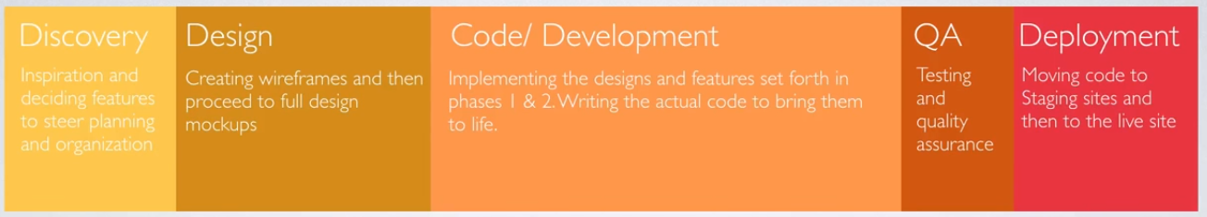

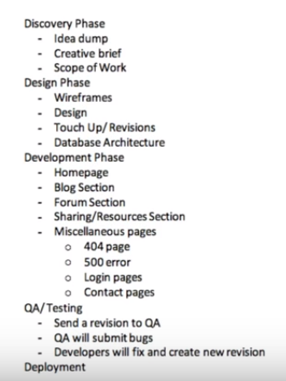

## Discovery(a.Idea Dump):(Discussing with client about the requirement. Just write all ideas what is on mind with thinging about how to implement those)

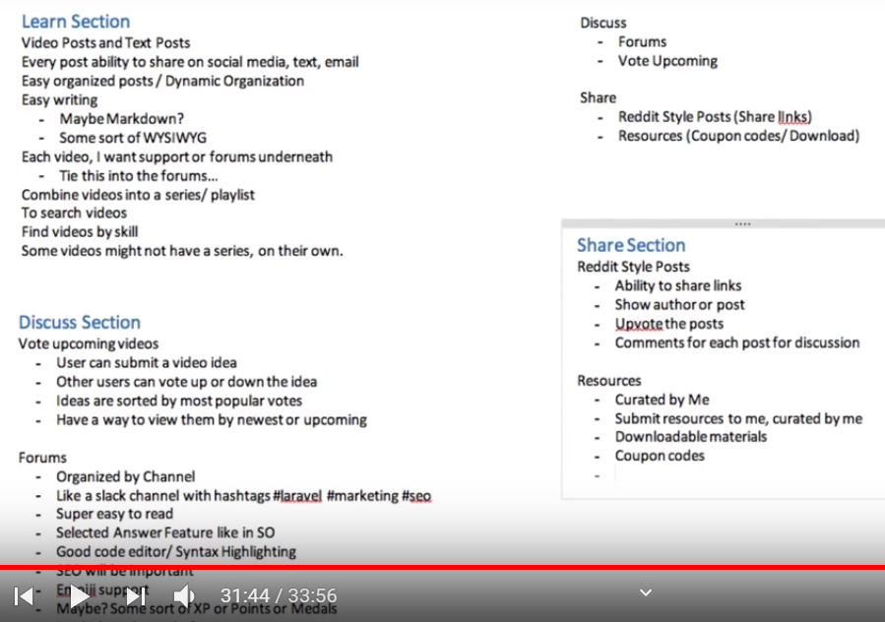

## b. Creating the Creative brief for the internal team, highlighting all the requirement of client in technical terms(It is for internal use, not for sharing with client)

## Scope of Work(Need to be signed by the client, mentioning all the features which we agreed upon)